Section I: Scenario Demographics

Scenario Title: | Pancreatitis with ARDS
Date of Development: | 29/06/2015 (DD/MM/YYYY)
Target Learning Group: | Juniors (PGY 1 – 2) Seniors (PGY ≥ 3) All Groups

Section II: Scenario Developers

Scenario Developer(s): | Kyla Caners
Affiliations/Institution(s): | McMaster University
Contact E-mail (optional): | kcaners@gmail.com

Section III: Curriculum Integration

Learning Goals & Objectives
Educational Goal: | To enhance resuscitation and team management skills.
CRM Objectives: | Communicate effectively with team members in the care of a complex, critically ill patient.
Medical Objectives: | - Begin broad diagnostic workup while simultaneously resuscitating a critically ill patient.  - Perform aggressive fluid resuscitation and identify when vasopressor required.  - Recognize onset of ARDS and demonstrate safe approach to intubating hypotensive patient with ARDS.

Case Summary: Brief Summary of Case Progression and Major Events
A 50 year-old female who was “on a bender” over the weekend now presents with diffuse abdominal pain and persistent nausea and vomiting. She will have a diffusely tender abdomen, a BP of 80/40, and be tachycardic. The team will need to work through a broad differential diagnosis and should fluid resuscitate aggressively. Once the patient has received 6L of fluid, she will become tachypneic and hypoxic and require intubation. The team will be given a lipase result just prior.

References
Marx, J. A., Hockberger, R. S., Walls, R. M., & Adams, J. (2013). Rosen's emergency medicine: Concepts and clinical practice. St. Louis: Mosby.

Section IV: Scenario Script

A. Scenario Cast & Realism
Patient: | Computerized Mannequin |  |  |  |  | Realism:  Select most important dimension(s) |  |  | Conceptual
 | Mannequin |  |  |  |  |  |  |  | Physical
 | Standardized Patient |  |  |  |  |  |  |  | Emotional/Experiential
 | Hybrid |  |  |  |  |  |  |  | Other:
 | Task Trainer |  |  |  |  |  |  |  | N/A
Confederates | Brief Description of Role
None required.
B. Required Monitors
EKG Leads/Wires |  |  | Temperature Probe |  |  |  | Central Venous Line
NIBP Cuff |  |  | Defibrillator Pads |  |  |  | Capnography
Pulse Oximeter |  |  | Arterial Line |  |  |  | Other:
C. Required Equipment
Gloves |  |  | Nasal Prongs |  |  |  | Scalpel
Stethoscope |  |  | Venturi Mask |  |  |  | Tube Thoracostomy Kit
Defibrillator |  |  | Non-Rebreather Mask |  |  |  | Cricothyroidotomy Kit
IV Bags/Lines |  |  | Bag Valve Mask |  |  |  | Thoracotomy Kit
IV Push Medications |  |  | Laryngoscope |  |  |  | Central Line Kit
PO Tabs |  |  | Video Assisted Laryngoscope |  |  |  | Arterial Line Kit
Blood Products |  |  | ET Tubes |  |  |  | Other:
Intraosseous Set-up |  |  | LMA |  |  |  | Other:
D. Moulage
None required. (Could choose to put a paper bag with empty beer bottle in it beside patient.)

E. Approximate Timing
Set-Up: |  | 3 min |  | Scenario: | 12 min |  |  | Debriefing: |  | 15 min

Section V: Patient Data and Baseline State

A. Clinical Vignette: To Read Aloud at Beginning of Case
Patricia is a 50 year old female who presents with epigastric abdominal pain. It’s been persistent for the last 24 hours and radiates through to her back. She has been nauseous all day and has been vomiting so much she “can’t keep anything down.” She was “on a bender” this weekend drinking beer and whiskey.
B. Patient Profile and History
Patient Name: Patricia Abrams |  |  |  |  |  | Age: 50 |  |  |  |  |  |  |  | Weight: 60kg
Gender: M F |  |  |  |  |  | Code Status: Full
Chief Complaint: Abdominal pain
History of Presenting Illness: Has been on a bender for the last few days. Now having worsening epigastric abdominal pain and persistent nausea and vomiting. Unable to keep anything down.
Past Medical History: |  | EtOH abuse |  |  |  |  | Medications: |  |  |  |  | HCTZ 25mg daily – doesn’t take
 |  | HTN
Allergies: sulfa – rash
Social History: Smokers 1ppd. Drinks heavily on weekends in binges. Has never had withdrawal.
Review of Systems: |  | CNS: |  |  | Feels dizzy and weak when stands.
 |  | HEENT: |  |  | Nil.
 |  | CVS: |  |  | No CP.
 |  | RESP: |  |  | Mild SOB.
 |  | GI: |  |  | Epigastric umbilical pain that bores into her back. Nausea with emesis all day. “Can’t keep anything down.” Loose BM x1 this am.
 |  | GU: |  |  | Nil.
 |  | MSK: |  |  | Nil. |  |  |  |  |  |  |  | INT: |  | Nil.
C. Baseline Simulator State and Physical Exam
No Monitor Display |  |  |  | Monitor On, no data displayed |  |  |  |  |  |  | Monitor on Standard Display
HR: 125/min |  |  | BP: 80/40 |  |  |  |  | RR: 20/min |  |  |  |  |  |  | O₂SAT: 93% RA
Rhythm: Sinus tach |  |  | T: 35.9ºC |  |  |  |  | Glucose: 5.8 mmol/L |  |  |  |  |  |  | GCS: 15 (E4 V5 M6)
General Status: Looks unwell.
CNS: | Alert and oriented.
HEENT: | PERLA, 3mm, normal EOM. No signs HI.
CVS: | Normal, no murmur.
RESP: | GAEB. Fine crackles at bases. Mildly tachypneic.
ABDO: | Soft, but diffusely tender. Maximal tenderness over epigastrum.
GU: | Nil.
MSK: | Nil. |  |  |  |  |  |  |  | SKIN: | Nil. (No jaundice.)

Scenario States, Modifiers and Triggers
Patient State | Patient Status | Learner Actions, Modifiers & Triggers to Move to Next State
1. Baseline State  Rhythm: Sinus tach  HR: 125/min  BP: 80/40  RR: 20/min  O₂SAT: 93% RA  T: 35.9ºC | Alert. Complaining of diffuse abdo pain. Retching. | Learner Actions  - Monitors, apply oxygen  - 2 IVs, start NS bolus x2L  - Blood work (abdo/cardiac)  - Analgesia & anti-emetic  - ECG  - Upright AXR – R/o free air  - Cap sugar – 5.8  - Broad spectrum antibiotics  - Bedside U/S r/o FF or AAA | Modifiers  Changes to patient condition based on learner action  - O₂ applied sats to 95%  - Analgesia HR to 120  - Anti-emetic stops retching  Triggers  For progression to next state  - 2L bolus or 5 min 2. Fluid non-responsive
2. Fluid Non-Responsive  BP 70/30  HR 130 | Patient still alert, but less talkative. Groaning a little. | Learner Actions  - Bedside U/S (if not yet done)  - Give 2L NS again (4L total)  - Start vasopressor | Modifiers  - 4L IVF total BP 85/45  Triggers  - 4-6L IVF given 3. Hypoxic  - 8 min 3. Hypoxic
3. Hypoxic  O₂SAT slow drop to 85%  RR 24 | **Start state by giving lipase result**  Diffuse crackles. Increased WOB. | Learner Actions  - Apply O₂ or increase O₂  - Prepare for intubation  - BVM when O₂ not improving (add PEEP/BiPap)  - CXR  - Prepare for intubation | Modifiers  - BVM O₂SAT 88%  - Bipap or BVM with PEEP valve O₂SAT 92%  Triggers  - Intubation 4. Intubation
4. Intubation  Vitals as per previous state |  | Learner Actions  - Apneic oxygenation  - Consider Bipap as bridge to intubation (or BVM with PEEP)  - Ketamine for induction  - Vasopressor at bedside  - Administer paralytic | Modifiers  - Bipap or BVM with PEEP valve O₂SAT 92%  Triggers  - Successful intubation  4. Resolution
4. Resolution  O₂SAT 94%  RR 12 (Vented)  HR 110  BP 85/45 | Intubated & sedated. | Learner Actions  - Call ICU  - Post-intubation CXR  - Lung-protective vent settings (TV 6-8ml/kg)  - Insert foley  - Insert OG  - Titrate vasopressors  - Start sedation | ICU arrives END CASE
Section VI: Scenario Progression

Section VII: Supporting Documents, Laboratory Results, & Multimedia

Laboratory Results
Na: 131 | K: 3.1 |  |  | Cl: 100 |  | HCO₃: 8 |  | BUN: 10 |  | Cr: 132 |  |  | Glu: 13
VBG |  | pH: 7.15 |  |  | PCO₂: 26 |  | PO₂: 45 |  | HCO₃: 8 |  |  | Lactate: 6
WBC: 22 |  |  | Hg: 110 |  |  |  | Hct: 0.27 |  |  |  | Plt: 145
TB: 12 |  |  | GGT: 50 |  |  |  | ALP: 26 |  |  |  | AST: 45
Lipase 1000 |  |  |  |  |  |  | INR 1.4
Images (ECGs, CXRs, etc.)
ECG – sinus tachycardia  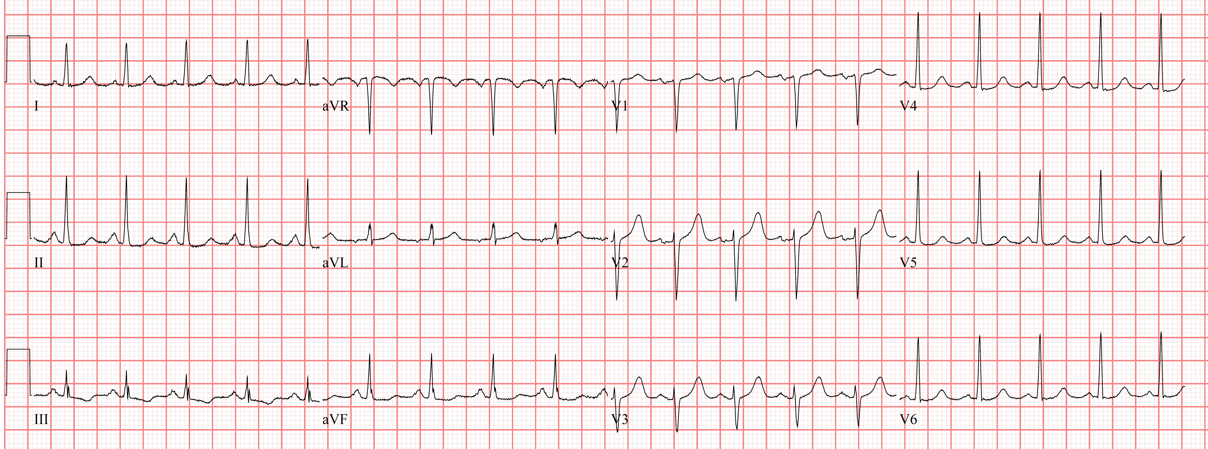  ECG source: http://cdn.lifeinthefastlane.com/wp-content/uploads/2011/12/sinus-tachycardia.jpg | CXR – initial (normal)  (Use same image if ask for AXR for free air)  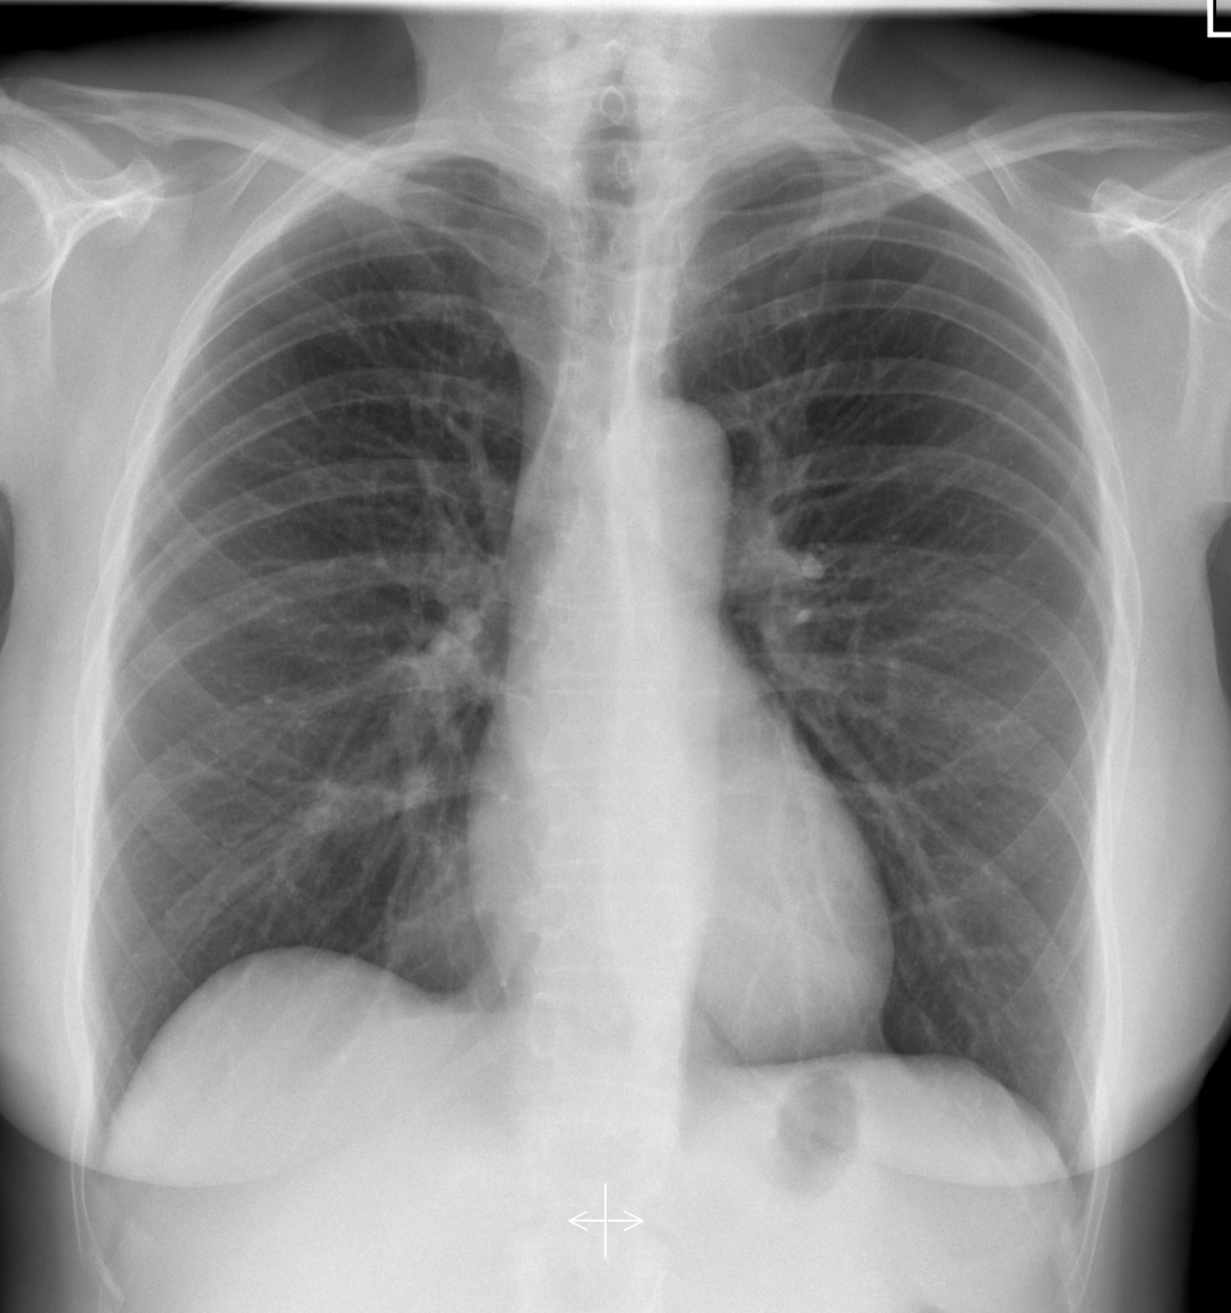  Source: http://radiopaedia.org/articles/normal-position-of-diaphragms-on-chest-radiography
CXR – with hypoxia (ARDS)  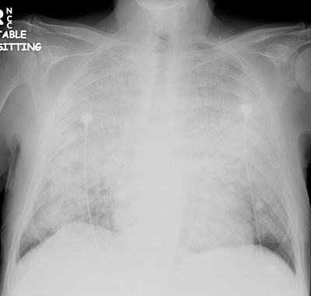  CXR source: http://www.radiology.vcu.edu/programs/  residents/quiz/pulm_cotw/PulmonConf/09-03-04/68yM%2008-03-04%20CXR.jpg | CXR – post intubation (ARDS)  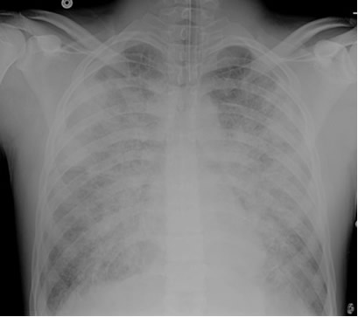  CXR source: http://courses.washington.edu/  med620/images/mv_c3fig1.jpg
Ultrasound Video Files (if applicable)
U/S abdomen – normal (no FF) | U/S aorta – normal (no AAA)
Pericardial U/S – normal (no effusion)

Section VIII: Debriefing Guide

General Debriefing Plan
Individual | Group |  | With Video | Without Video
Objectives
Educational Goal: |  | To enhance resuscitation and team management skills.
CRM Objectives: |  | Communicate effectively with team members in the care of a complex, critically ill patient.
Medical Objectives: |  | - Begin broad diagnostic workup while simultaneously resuscitating a critically ill patient.  - Perform aggressive fluid resuscitation and identify when vasopressor required.  - Recognize onset of ARDS and demonstrate safe approach to intubating hypotensive patient with ARDS.
Sample Questions for Debriefing
- What was on your differential diagnosis for this patient? What was your thought process when the patient’s blood pressure wasn’t responding to fluids?
- Why do you think the patient became hypoxic? Does that fit with the rest of the clinical picture?
- How did you attempt to optimize your patient’s oxygenation before intubation? Is there anything else you could have done in this clinical context?
- Do you feel that roles were allocated well in this scenario? Was it clear who was managing what?
Key Moments
Recognition of toxic patient
Recognition of fluid non-responsiveness
Management of hypoxia

